Probabilités : Exercices de type brevet

Exercice 1

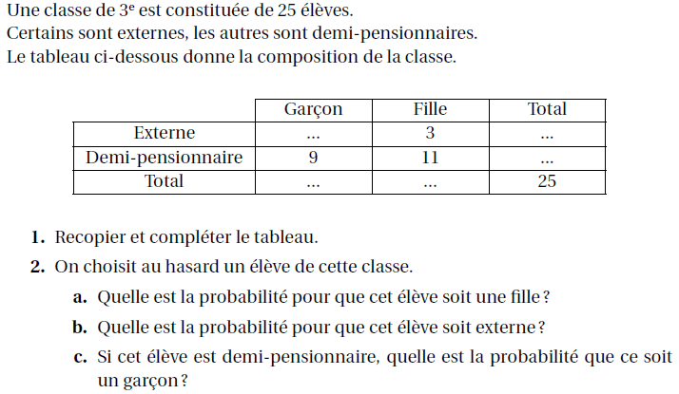

Exercice 2

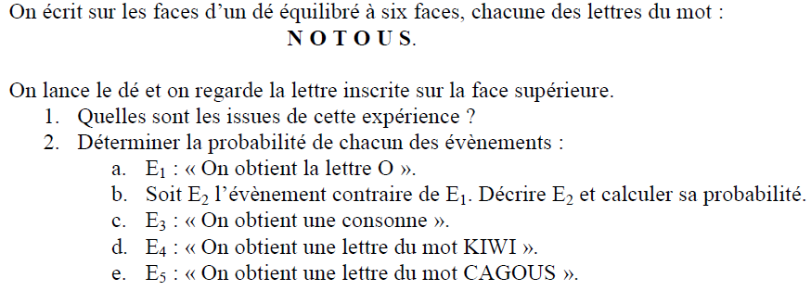

Exercice 3

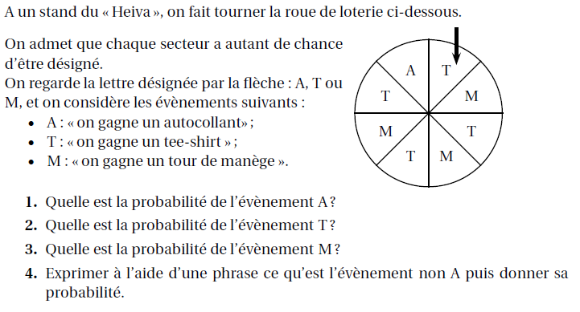

Exercice 4

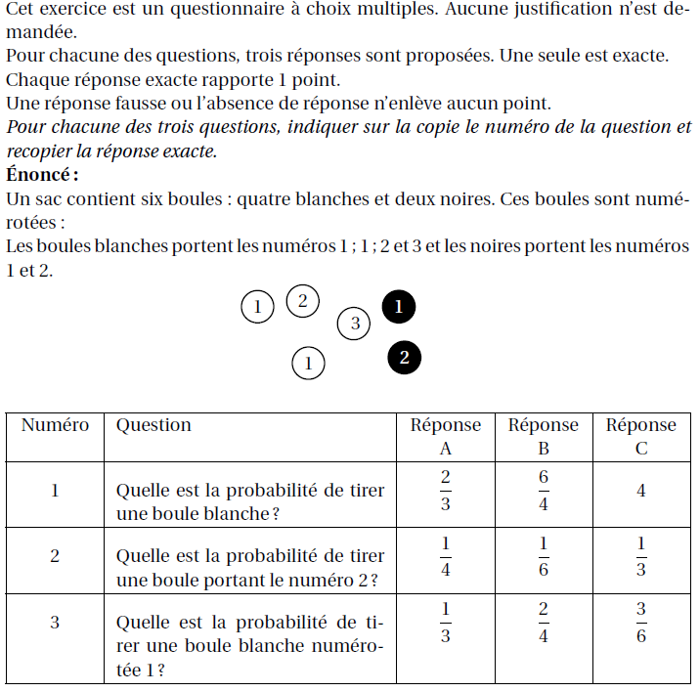

Exercice 5

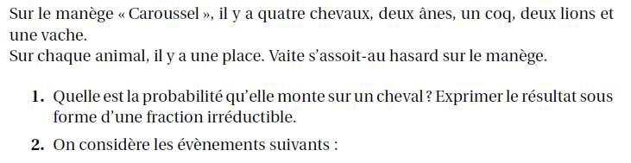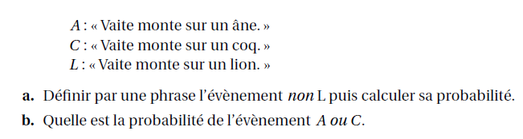

Exercice 6

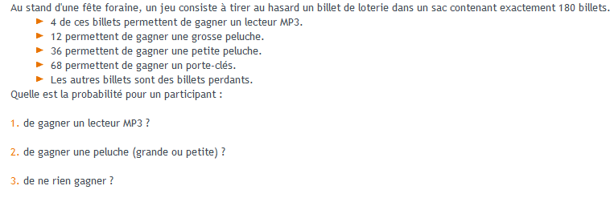
Exercice 7

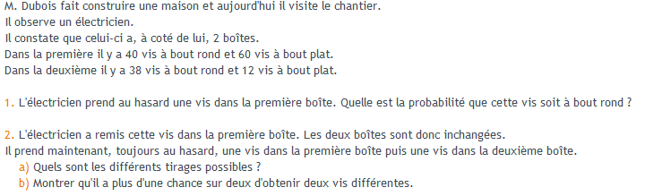

Exercice 8

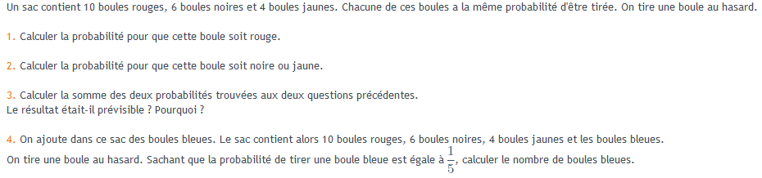

Exercice 9

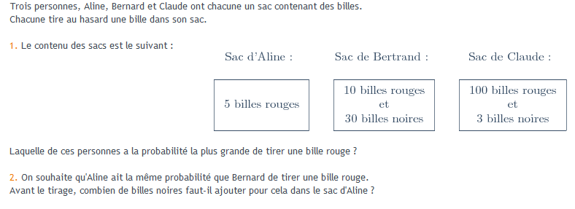

Exercice 10

